Additional Files
Additional file 1: List of primers used for the RT PCR analysis.
S.no | DEG | Genes | Primer | Sequences
1 |  | gyrB | Forward | CGAGGGTGACTCAGCGGGTG
1 |  | gyrB | Reverse | GCGCACGCTCAACGTTCAGG
2 | 126 Upregulated | Class C extended spectrum | Forward | CCTCAATTTATGCGGGCAATAC
2 | 126 Upregulated | Class C extended spectrum | Reverse | GCCATACCTGGCACATCATA
3 |  | Multidrug efflux RND | Forward | CCATATTTGCGTGGGTGATTG
3 |  | Multidrug efflux RND | Reverse | GTGGTGCAATCGTTGGATATTG
4 |  | OmpA family protein | Forward | GCGAATACACGACGGTTCATA
4 |  | OmpA family protein | Reverse | TGATGCTTCTCGTTTGTCTACTC
5 | 126 Downregulated | Transfer-messenger RNA | Forward | GCCGGTGATGAAACTCATAGA
5 | 126 Downregulated | Transfer-messenger RNA | Reverse | GTTTCGTCGTTTGCGACTATTT
6 |  | Iron-containing alcohol | Forward | GGAACCTAACCCAACCGATATT
6 |  | Iron-containing alcohol | Reverse | ACCGCCTAACGACACAATAAA
7 |  | Aldehyde dehydrogenase | Forward | GAAGTCTGGTATTGGTCGTGAA
7 |  | Aldehyde dehydrogenase | Reverse | GCCCATTGGTTTGGTTGAATAA
8 | ATCC 19606 Upregulated | Multidrug efflux | Forward | GGGTTGGTGAAGTCGGATTAT
8 | ATCC 19606 Upregulated | Multidrug efflux | Reverse | CACAATTTCAGTGGCTGTAAGG
9 |  | MFS transporter | Forward | CACAAGGTATTGAGGTGGGTAG
9 |  | MFS transporter | Reverse | AGCACCATAAGCGAGGAATAAA
10 |  | M1 family peptidase | Forward | GCTCAGATGTTTGTTGGGTATTG
10 |  | M1 family peptidase | Reverse | GCCAGTCATTTCCGTCATTTG
11 | ATCC 19606 Downregulated | Putative porin | Forward | TACGACGAGAAAGACGGTAAAG
11 | ATCC 19606 Downregulated | Putative porin | Reverse | GTCACCAAACGCACCATAAG
12 |  | Transfer-messenger RNA | Forward | GCCGGTGATGAAACTCATAGA
12 |  | Transfer-messenger RNA | Reverse | GTTTCGTCGTTTGCGACTATTT
13 |  | Trifunctional transcriptional regulator | Forward | GGGAAGTTCCATGGGCTAATAC
13 |  | Trifunctional transcriptional regulator | Reverse | AGTTCGTGAGGCTGTAGATTTC
DEGs: differentially expressed genes.

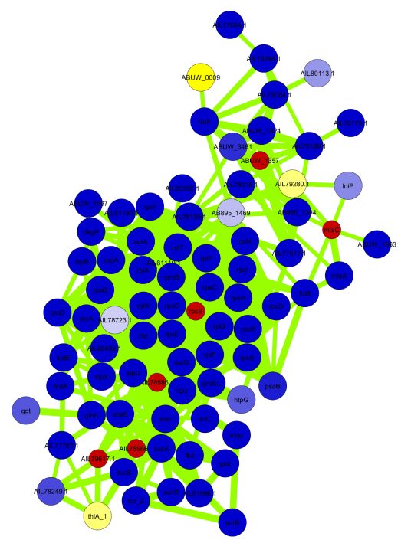  . | 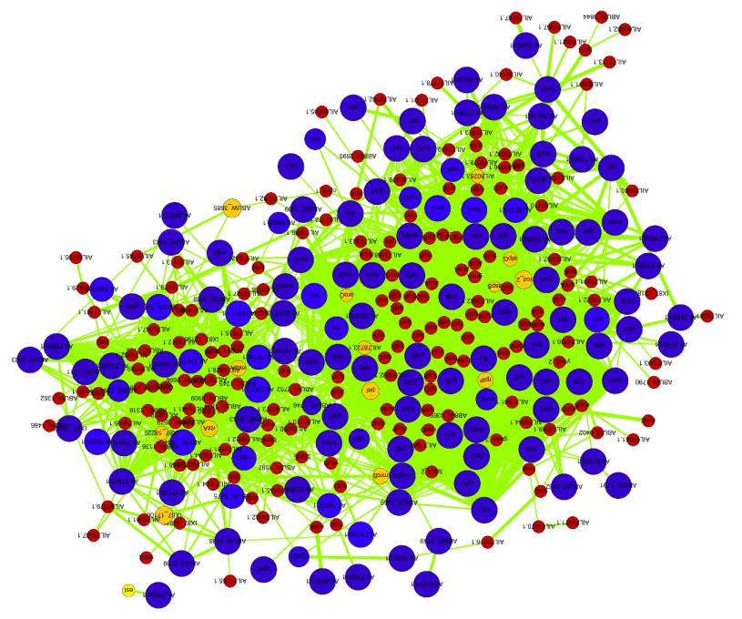
A | B

Additional file 6 FIGURE 1 | A, B: The PPI network of genes/proteins expressed commonly in transcriptome and OMVs proteome from A. baumannii ATCC 19606 and JU0126 strains. The blue and yellow nodes represent commonly identified genes/proteins from both mRNA and OMVs proteome and red nodes represents neighbouring proteins. The size of the blue and yellow nodes represented in p value and edge size of the PPI network were represented in combine score.

Additional file 7 | Subnetworks identified using MCODE plug-in in the PPI network of A. baumannii ATCC 19606 and JU0126strain.
Sub-network | MCODE score | Number of proteins (Nodes) | Number of interactions (Edges) | GO term Functions
ATCC
CLUSTER 1 | 51.321 | 54 | 1360 | ribosomal proteins, RNA polymerases, intracellular organelles, tRNA binding, regulation of translation
CLUSTER 2 | 10.600 | 11 | 53 | cell envelope organization
CLUSTER 3 | 9.882 | 18 | 84 | response to toxic substance
CLUSTER 4 | 7.200 | 11 | 36 | Proteins of unknown functions
JU0126
CLUSTER 1 | 23.333 | 25 | 280 | Ribosomal subunit, RNA polymerase, cellular macromolecular biosynthesis, cellular nitrogen compound biosynthetic process

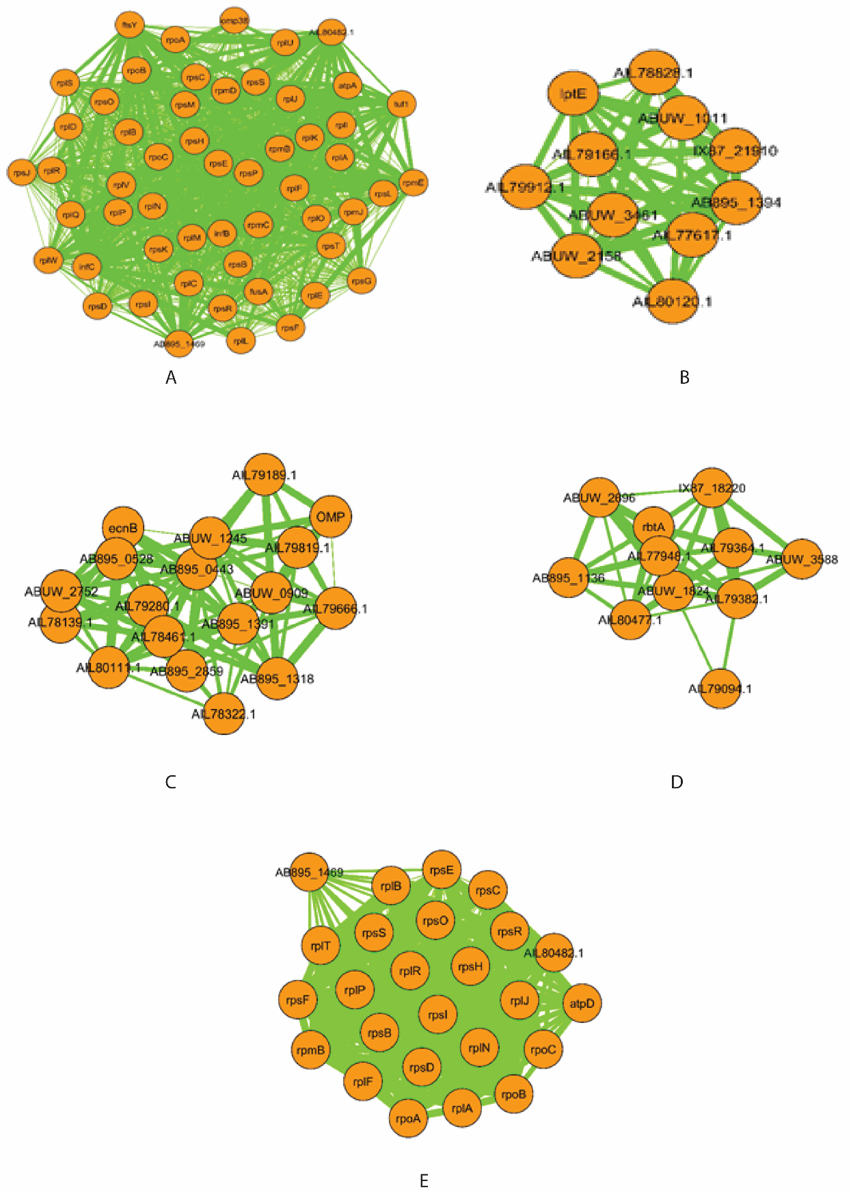

Additional file 8 : Schematic representation of MCODE clusters of A. baumannii ATCC 19606 (A-D) and JU0126 (E) strains. Nodes colors represent in orange color, and the size of edges was represented in combine score in PPI network.

